Name: Saša Mijalković
E-mail: sasa.mijalkovic@kpa.edu.rs
Institution: Academy for Criminalistic and Police Studies, Belgrade, Republic of Serbia
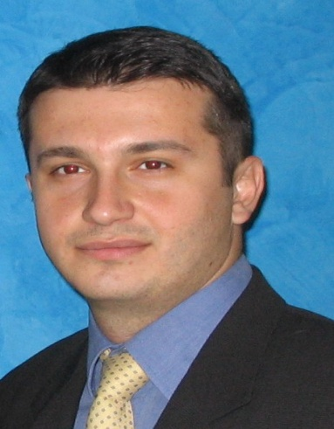 | Saša Mijalković is a Full Professor (National Security, Methodology of Intelligence − Undergraduate Studies; Phenomenology of Security threats, Methodology of Scientific Researching, Terrorism and Political Violence − Postgraduate Studies) at Academy of Criminalistic and Police Studies, Belgrade.  Also, he is guesting Full Professor (Research Methodology of Security Phenomena, National Security Sistems − Undergraduate Studies) at Faculty of Law, University of Montenegro, and a guesting Full Professor (Security Sistems − Undergraduate Studies) at Faculty of Law, University of Kragujevac.  The Ministry of education and science of Republic of Serbia classified his overall research work in the highest − A1 category, allotted him the status of outstanding young scientists and entrusted the management of two science research projects of national importance: Prevention and suppression of contemporary forms of crime (2006−2010) and the Development of institutional capacity, standards and procedures for combating organized crime and terrorism in the conditions of international integration (2011−2017).
References (max. 5 relevant references)
1. Mijalković S.: National security. Belgrade: Academy of Criminalistic and Police Studies, 2009, 2011, 2015. (textbook).
2. Mijalković S.: Countering human trafficking and smuggling of migrants - the possibilities of improving the security and law enforcement practices of national security systems. Belgrade: Official Gazette and the Institute of Comparative Law, 2009. (Monograph).
3. Mijalković S., Milosevic M.: Intelligence and security activities and services. Banja Luka: Higher School of Internal Affairs, 2011. (Monograph).
4. Mijalković S., Bajagić, M.: Organized crime and terrorism. Belgrade: Academy of Criminalistic and Police Studies, 2012. (Monograph).
5. Mijalković S., Popović, M: Intoduction into Security Studies. Belgrade: Academy of Criminalistic and Police Studies, 2015, 2016. (Monograph)
Project number: 573806-EPP-1-2016-1-RS-EPPKA2-CBHE-JP

"This project has been funded with support from the European Commission. This publication reflects the views only of the author, and the Commission cannot be held responsible for any use which may be made of the information contained therein"

